**ASSIGNMENT 3 (MEDIA AND FORMS)**

1. **Create an image gallery that holds multiple images.**

<!DOCTYPE html>

<html lang="en">

<head>

    <meta charset="UTF-8">

    <meta name="viewport" content="width=device-width, initial-scale=1.0">

    <title>Assignment 1</title>

</head>

<body>

    <img src="https://dummyimage.com/400x400" alt="Dummy image">

    <img src="https://dummyimage.com/500x500" alt="Dummy image">

    <img src="https://dummyimage.com/400x500" alt="Dummy image">

    <img src="https://dummyimage.com/600x500" alt="Dummy image">

    <img src="https://dummyimage.com/400x400" alt="Dummy image">

    <img src="https://dummyimage.com/600x400" alt="Dummy image">

    <img src="https://dummyimage.com/900x700" alt="Dummy image">

</body>

</html>

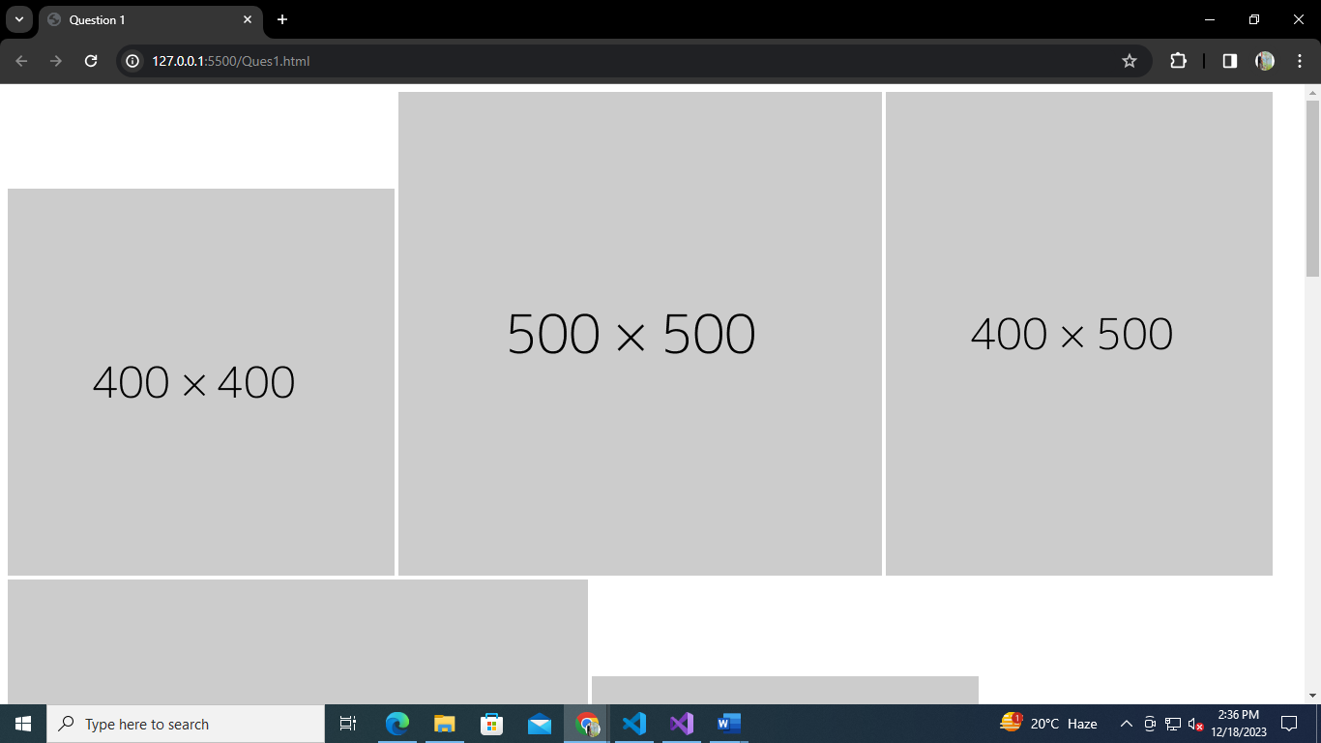**OUTPUT:-**

1. **Use video and audio to display video and audio with playback, audio controls.**

<!DOCTYPE html>

<html lang="en">

<head>

    <meta charset="UTF-8">

    <meta name="viewport" content="width=device-width, initial-scale=1.0">

    <title>Question 2</title>

</head>

<body>

    <audio src="/audio.mp3" controls></audio>

    <br>

   <video src="/video.mp4" controls></video>

</body>

</html>

**OUTPUT: -**

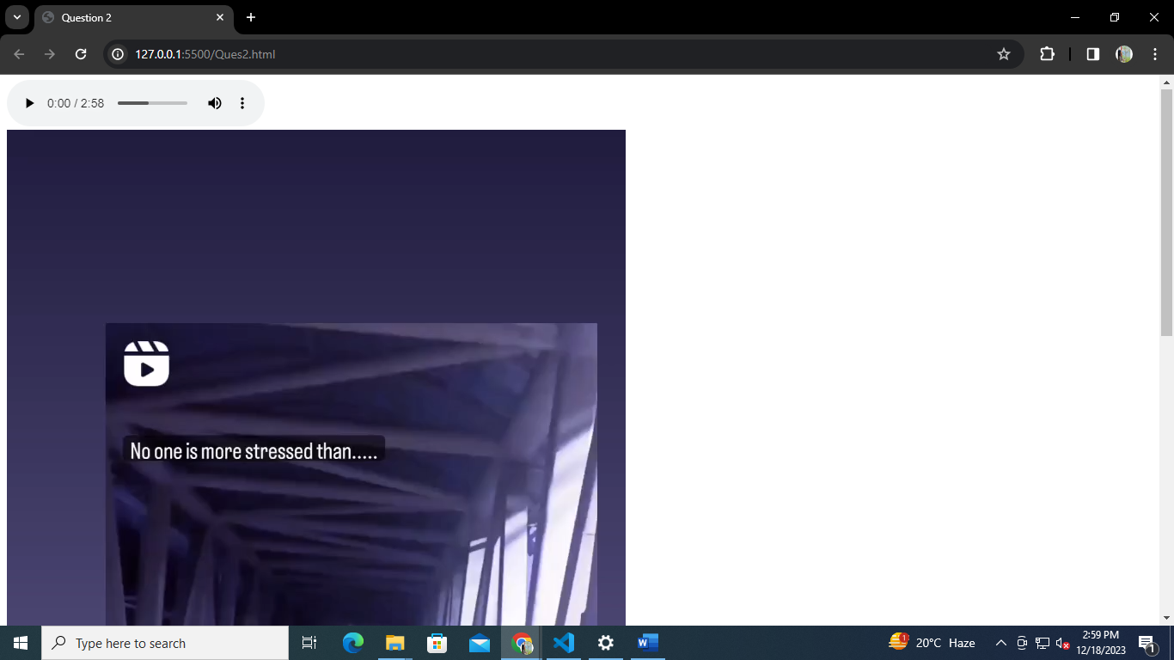

1. **Modify the previous assignment so that the audio and video play automatically as the page is loaded and they should paly infinitely.**

<!DOCTYPE html>

<html lang="en">

<head>

    <meta charset="UTF-8">

    <meta name="viewport" content="width=device-width, initial-scale=1.0">

    <title>Question 3</title>

</head>

<body>

    <audio src="/audio.mp3" controls muted autoplay loop></audio>

    <br>

    <video src="/video.mp4" controls muted autoplay loop></video>

</body>

</html>

**OUTPUT: -**

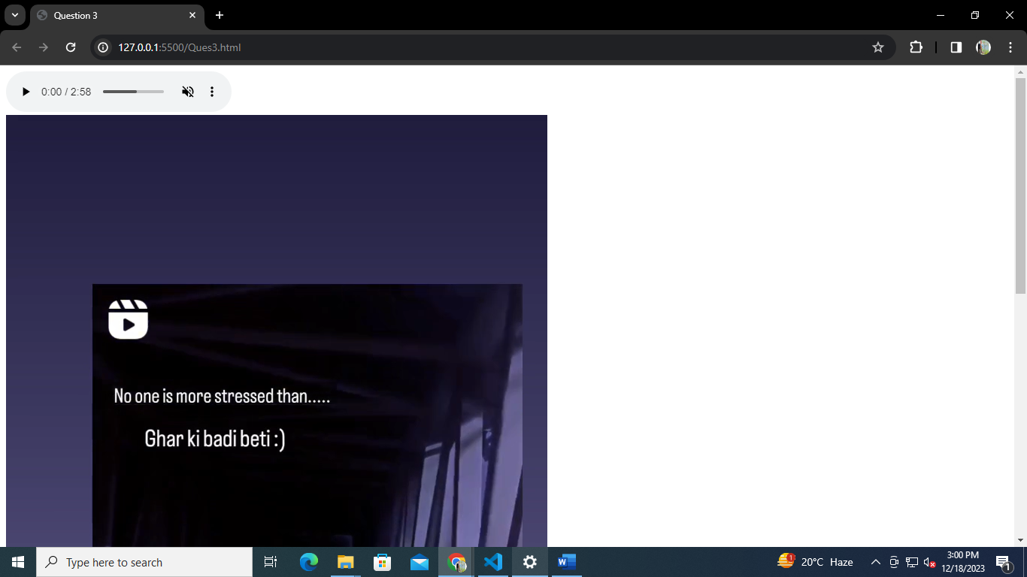

1. **Use iframe to embed the PhysicsWallah Wikipedia page properly.**

<!DOCTYPE html>

<html lang="en">

<head>

    <meta charset="UTF-8">

    <meta name="viewport" content="width=device-width, initial-scale=1.0">

    <title>QUESTION 4</title>

</head>

<body>

    <iframe src="https://en.wikipedia.org/wiki/Physics_Wallah" style="border:0px #ffffff none;" name="myiFrame"

        scrolling="yes" frameborder="1" marginheight="0px" marginwidth="0px" height="631px" width="1355px"

        allowfullscreen></iframe>

</body>

</html>

**OUTPUT: -**

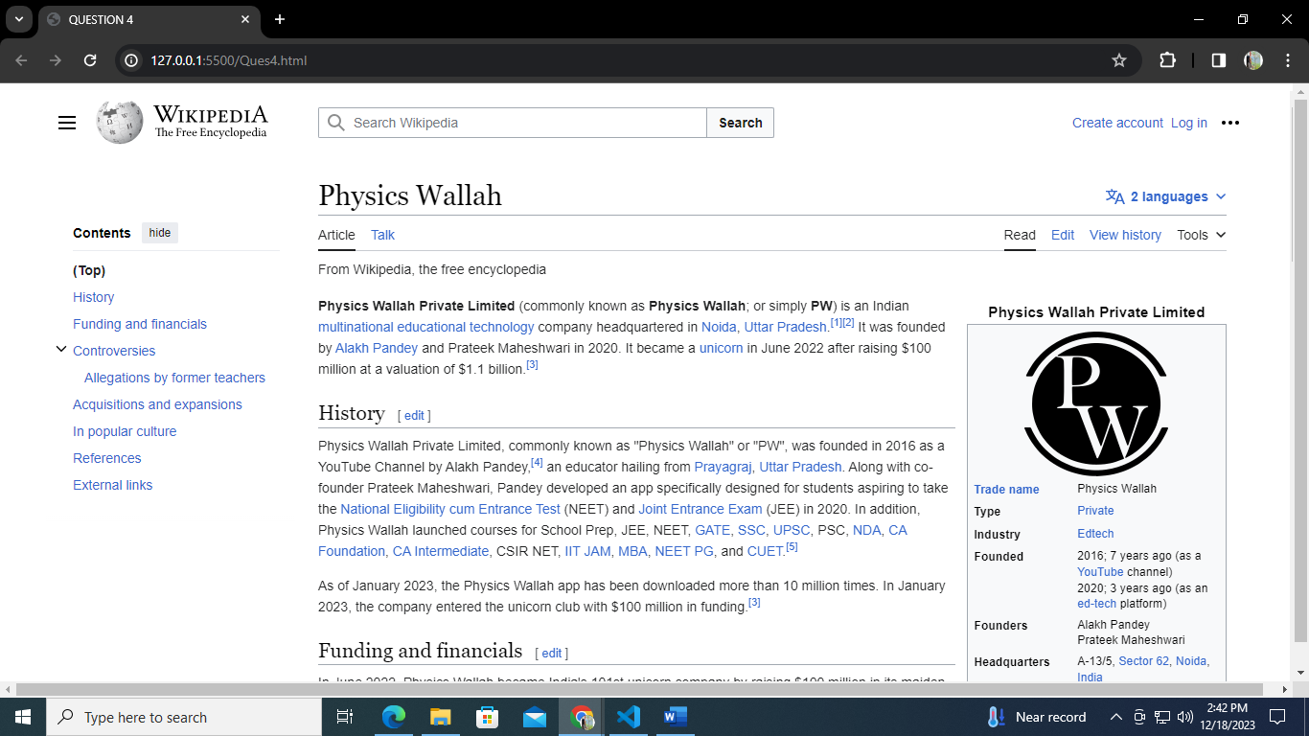

1. **Create a sign-in and sign-up form with proper validation.**
   1. **Sign-Up form should have a first name, last name, email, Password, confirm password, age, gender and agree to terms and conditions fields at minimum (You can add any other if you like)**

<!DOCTYPE html>

<html lang="en">

<head>

    <meta charset="UTF-8">

    <meta name="viewport" content="width=device-width, initial-scale=1.0">

    <title>Sign Up</title>

    <style>

        .cont {

            margin-top: 5%;

            margin-left: 5%;

        }

        .row {

            display: flex;

            line-height: 1.5;

            padding: 7px 0 8px 0;

        }

        label {

            flex: 0 0 auto;

            width: 16.66666667%;

            font-size: 20px;

        }

        input {

            padding: 8px;

        }

    </style>

</head>

<body>

    <div class="cont">

        <form>

            <div class="row">

                <label for="firstName">First Name:</label>

                <div>

                    <input type="text" name="firstName" placeholder="John" id="firstName" required minlength=3 max=20 />

                </div>

            </div>

            <div class="row">

                <label for="lastName">Last Name:</label>

                <div>

                    <input type="text" name="lastName" placeholder="Doe" id="lastName" required min=3 max=20 />

                </div>

            </div>

            <div class="row">

                <label for="email">Email:</label>

                <div>

                    <input type="email" name="email" placeholder="johnWdoe.com" id="email" required />

                </div>

            </div>

            <div class="row">

                <label for="password">Password:</label>

                <div>

                    <input type="password" name="password" placeholder="********" id="password" required min=8 />

                </div>

            </div>

            <div class="row">

                <label for="confirmPassword">Confirm Password:</label>

                <div>

                    <input type="password" name="confirmPassword" placeholder="********" id="confirmPassword"

                        required />

                </div>

            </div>

            <div class="row">

                <label for="">Gender:</label>

                <div>

                    <input type="radio" id="male" value="male" name="gender" checked />

                    <label for="male">Male</label>

                    <input type="radio" id="female" value="female" name="gender" />

                    <label for="female">Female</label>

                    <input type="radio" id="other" value="other" name="gender" />

                    <label for="other">Other</label>

                </div>

            </div>

            <div class="row">

                <label for="terms">Terms and conditions:</label>

                <div>

                    <input type="checkbox" id="terms" required /> agree to terms and conditions

                </div>

            </div>

            <button type="submit">Sign Up</button>

        </form>

    </div>

</body>

</html>

**OUTPUT: -**

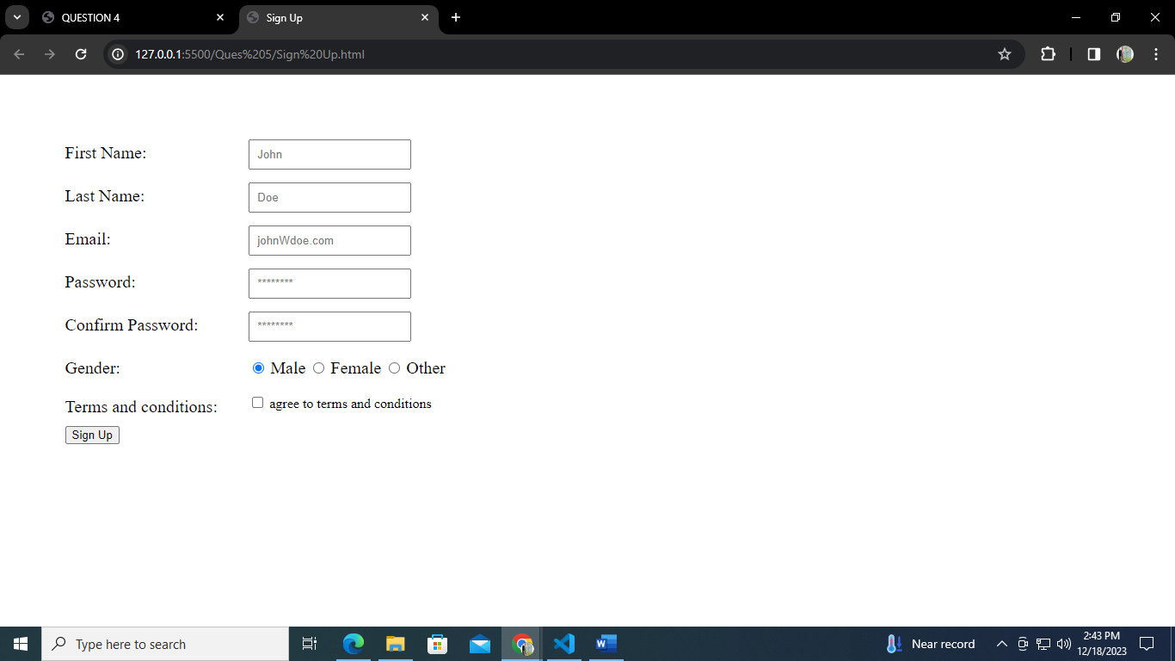

* 1. **Sign-In form should have email, password fields**

<!DOCTYPE html>

<html lang="en">

<head>

    <meta charset="UTF-8">

    <meta name="viewport" content="width=device-width, initial-scale=1.0">

    <title>Sign Up</title>

    <style>

        .cont {

            margin-top: 5%;

            margin-left: 5%;

        }

        .row {

            display: flex;

            line-height: 1.5;

            padding: 7px 0 8px 0;

        }

        label {

            flex: 0 0 auto;

            width: 16.66666667%;

            font-size: 20px;

        }

        input {

            padding: 8px;

        }

    </style>

</head>

<body>

    <div class="cont"><h2>SIGN IN</h2>

    </div>

    <div class="cont">

        <form>

            <div class="row">

                <label for="email">Email:</label>

                <div>

                    <input type="email" name="email" placeholder="johnWdoe.com" id="email" required />

                </div>

            </div>

            <div class="row">

                <label for="password">Password:</label>

                <div>

                    <input type="password" name="password" placeholder="********" id="password" required min=8 />

                </div>

            </div>

            <button type="submit">Sign In</button>

        </form>

    </div>

</body>

</html>

**OUTPUT: -**

